Mean-Reversion Trading Strategies Across Assets and Averaging Horizons: An Exploratory Backtest Study

1. Idea
Our aim was to analyze the evolution of cumulative profit and loss generated by simple mean-reversion trading strategies applied to different financial assets. In particular, we investigated how the performance of these strategies depends on the averaging horizon used to estimate the reference price level.
The analysis focuses on several assets with different characteristics (stocks, index and cryptocurrency) and compares active trading strategies with a passive buy-and-hold benchmark. The objective is not to identify an optimal strategy, but rather to explore how asset class, averaging horizon and transaction costs influence strategy behaviour.

2. Methodology

2.1 Data

Hourly historical data were downloaded using the Python package yfinance. Five assets were analyzed:
- AAPL
- SPY
- BTC-USD
- XOM
- JPM
Depending on the averaging horizon, historical periods from one to two years were used to ensure sufficient observations for rolling calculations. Nevertheless, all strategies were evaluated over approximately the interval 04/29/2025 – 04/29/2026. Intraday availability differed among assets due to Yahoo Finance limitations.

2.2 Trading signal
For every trading hour, rolling mean values and rolling standard deviations were computed over several averaging horizons:
- last 20 trading hours
- last 1 month
- last quarter
- last half-year
- last 1 year
The z-score was defined as
$z_{t}= \frac{P_{t}-μ_{t}}{σ_{t}}$,
where $P_{t}$​ is current price, $μ_{t}$​ is rolling mean and $σ_{t}$​ is rolling standard deviation. The index $t$ stands for particular record. The trading rules are
$$position_{t}= \left\{\begin{aligned}1 z_{t}<-1 \\ -1 { z}_{t}>1 \\ 0 otherwise\end{aligned}\right.$$
Thus:
- long position → expected growth
- short position → expected decrease
- zero position → no exposure

2.3 Portfolio construction
For each record, we defined
strategy return:
$strategy_{t}=position_{t}⋅return_{t}$,
$$return_{t}=\frac{P_{t}-P_{t-1}}{P_{t-1}}$$
portfolio equity:
$$equity_{t}=∏\left(1+strategy_{t}\right)$$
buy-and-hold equity:
$$equity_{t(buyhold)}=∏\left(1+return_{t}\right)$$

2.4 Performance measures
Strategies were evaluated using:

Total return
$$Total return=equity_{final}-1$$

Sharpe ratio
$$Sharpe=\frac{\sqrt{N}∙mean\left(strategy\right)}{std\left(strategy\right)}$$
where $\sqrt{N}$ denotes annualization factor.

Maximum drawdown
- it is largest decline from previously achieved portfolio maximum:
$$Drawdown_{t}=\frac{equity_{t}}{\max\left(equity_{≤t}\right)}-1,$$
$$MaxDD=min(Drawdown)$$

2.5 Backtest assumptions
The analysis assumes execution at observed hourly prices, fixed position size and no leverage. Market impact and slippage are neglected, meaning that trades are assumed to occur exactly at recorded prices.
Furthermore, no parameter optimization was performed. Trading positions were shifted by one period to avoid look-ahead bias, ensuring that decisions relied only on previously available information.

3. Results

3.1 Influence of averaging horizon: AAPL
For AAPL, all investigated averaging horizons are shown.
Figure 1: buy-and-hold Figure 2: AAPL — 20h
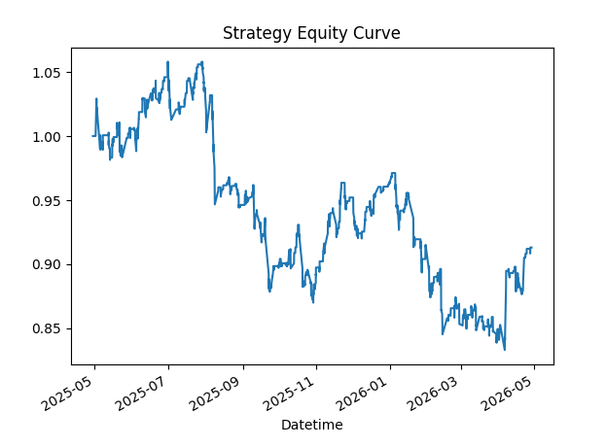
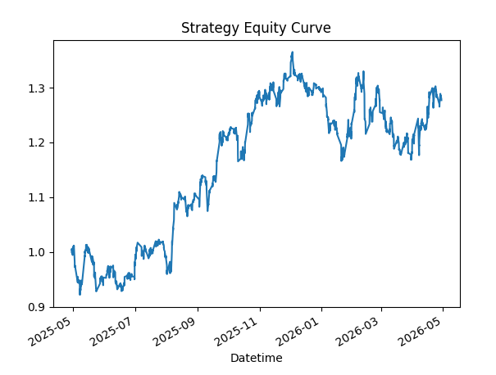
Figure 3: AAPL — 1 month Figure 4: AAPL — quarter
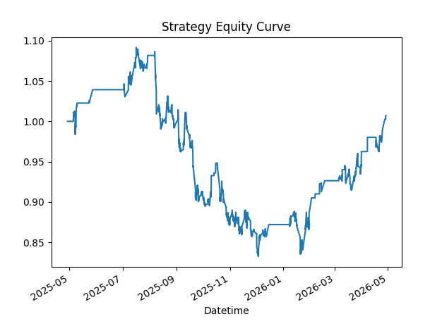
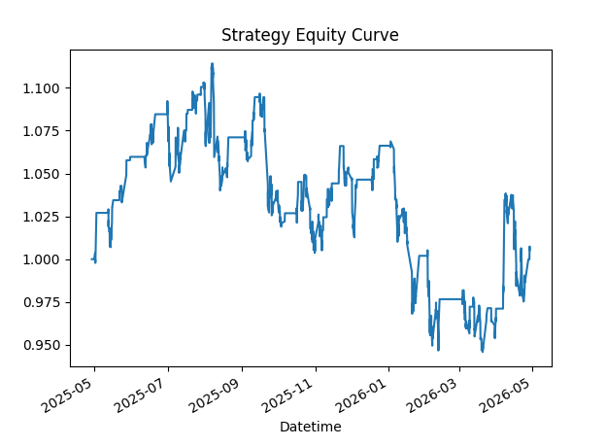

Figure 5: AAPL — half year Figure 6: AAPL — one year
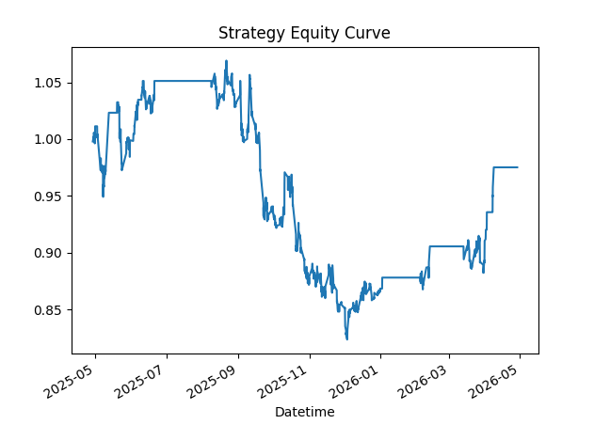
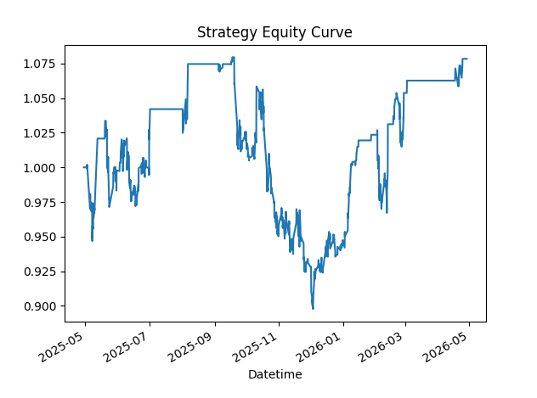

Interpretation:
For AAPL, buy-and-hold outperformed active trading strategies.

3.2 Best-performing configurations across assets

Performance appears sensitive to averaging horizon, but no universal relationship between averaging horizon and profitability was observed. Considering total return, we present the best-performing strategies for each asset. In most investigated cases, it is buy-and-hold (for AAPL see Fig. 1), but some exceptions appeared.

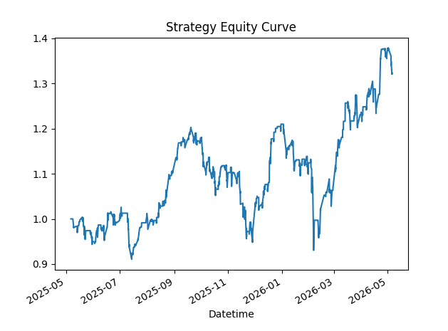
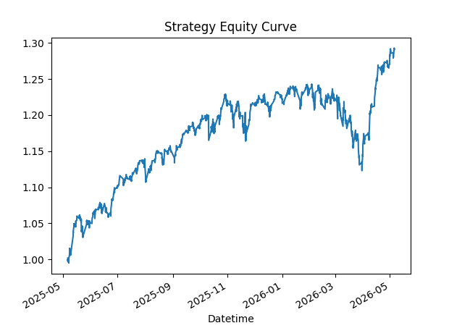
Figure 7: SPY (buy-and-hold) Figure 8: BTC (20h)

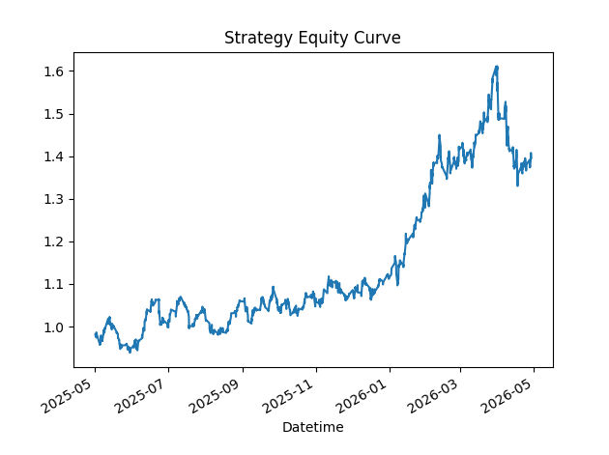
Figure 9: XOM (buy-and-hold)

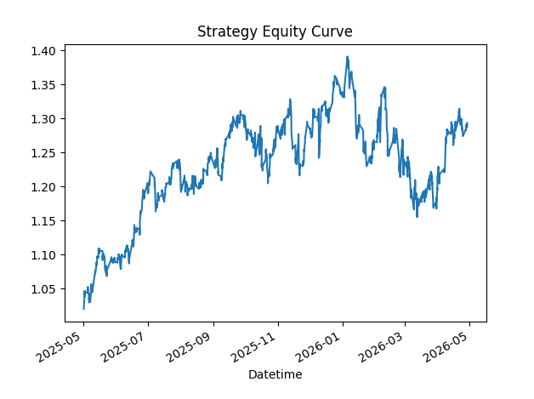
Figure 10: JPM (20h and buy-and-hold)

The characteristics of the announced best strategies are outlined in Table 1.

Table 1: Best trading strategies.
Asset | Window | Total return | Sharpe | Max DD
AAPL | Buy-and-Hold | 28.4% | 0.45 | -14.58%
SPY | Buy-and-Hold | 29.4% | 0.76 | -9.65%
BTC | 20h | 37.4% | 0.44 | -23.10%
XOM | Buy-and-Hold | 39.6% | 0.57 | -17.46%
JPM | 20h | 28.3% | 0.60 | -8.04%
JPM | Buy-and-Hold | 28.8% | 0.46 | -16.96%

4. Impact of transaction costs
The previous analysis neglected transaction costs.
More realistic returns may be written as:
$${strategy}_{t}^{net}={strategy}_{t}-cost ∙ \left|position_{t}-position_{t-1}\right|$$
Net equity:
$${equity}_{t}^{net}=∏\left(1+{strategy}_{t}^{net}\right)$$
Transaction cost:
$$cost=0.0005$$
Buy-and-hold strategies remained unchanged under this implementation,
because no repeated position changes were generated during the backtest.
For most assets, transaction costs had only minor influence. However, several highly active strategies exhibited substantial deterioration. In Table 2, the best strategies for the investigated assets announced in Table 1 are evaluated again with the consideration of transaction costs. The only changes are connected with other trading strategies than buy-and-hold. They are highlighted in bold.

Table 2: Best trading strategies with transaction costs considered.
Asset | Window | Total return | Sharpe | Max DD
AAPL | Buy-and-Hold | 28.4% | 0.45 | -14.58%
SPY | Buy-and-Hold | 29.4% | 0.76 | -9.65%
BTC | 20h | 15.3% | 0.23 | -27.59%
XOM | Buy-and-Hold | 39.6% | 0.57 | -17.46%
JPM | 20h | 5.1% | 0.15 | -10.00%
JPM | Buy-and-Hold | 28.8% | 0.46 | -16.96%

4.1 Representative examples

Behaviour for buy-and-hold strategies: no impact

Figure 11: SPY buy-and-hold (original vs transaction costs)
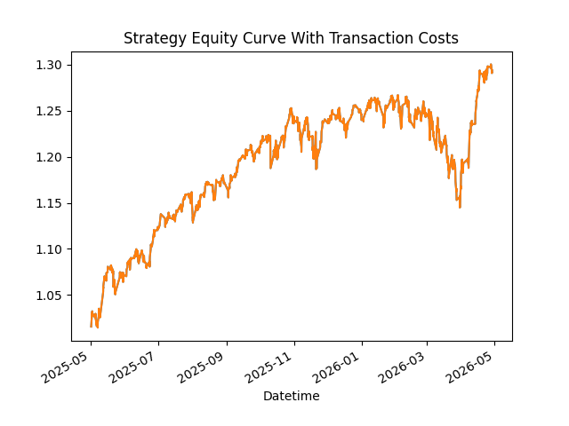
Interpretation:
Buy-and-hold strategies remained unchanged after introducing transaction costs because there was no trading activity.

Typical behavior: minimal impact

Figure 12: SPY 1 year (original vs transaction costs)
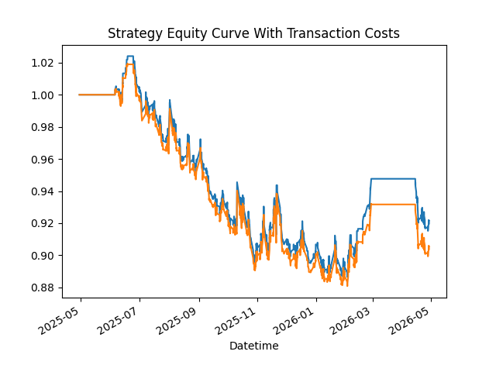
Interpretation:
Longer averaging horizons generated relatively few position changes and therefore accumulated only minor transaction costs.

Exceptional behavior: moderate impact

Figure 13: BTC 20h (original vs transaction costs)
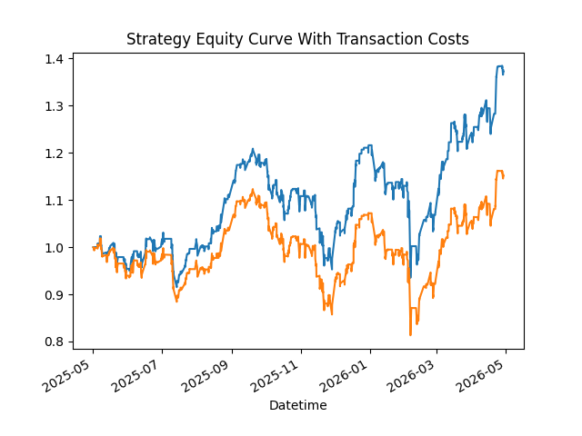

Interpretation:
Shorter averaging horizons generated more frequent position changes and therefore accumulated larger transaction costs, leading to visible deterioration of net performance.

Exceptional behavior: strong impact

Figure 14: SPY 20h (original vs transaction costs)
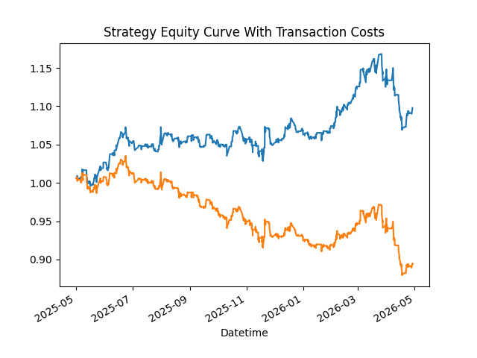

Interpretation:
SPY with short averaging horizon exhibited substantial
performance degradation after introducing transaction costs.
Across investigated assets, shorter averaging horizons tended to generate more frequent position changes and therefore accumulated larger transaction costs. Consequently, net performance often deteriorated more strongly than for strategies using longer averaging windows.

4.2 Profit-to-loss transition
Particularly illustrative examples occur for SPY with averaging horizon 20 trading hours (Fig. 14) and BTC with averaging horizon 1 month (Fig. 15).
Even modest transaction costs were sufficient to reverse profitability:
Table 3: Trading strategies with averaging horizons 20h for SPY and
1 month for BTC neglecting and considering transaction costs.
Asset | Window | Cost | Total return | Sharpe | Max DD
SPY | 20 h | 0 | +9.8% | 0.40 | -8.47%
SPY | 20 h | 0.0005 | -10.6% | -0.44 | -15.07%
BTC | 1 month | 0 | +2.6% | 0.09 | -25.37%
BTC | 1 month | 0.0005 | -3.6% | 0.02 | -25.44%

Figure 15: BTC 1 month (original vs transaction costs)
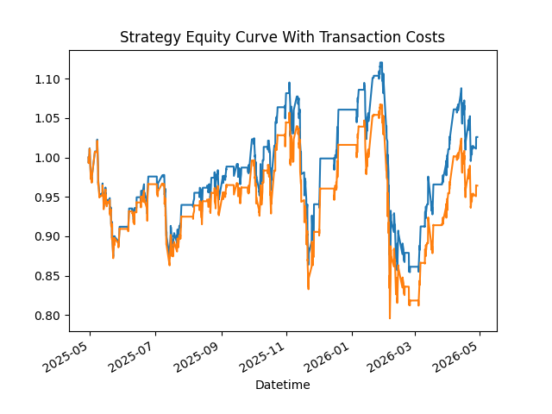

These examples demonstrate that profitable strategies may become unprofitable once realistic execution costs are incorporated.

5. Limitations
The present analysis intentionally uses a simplified mean-reversion framework and should therefore be interpreted as exploratory.
Fixed thresholds and averaging horizons were chosen without systematic parameter optimization. In addition, the investigated strategies were evaluated only within one historical period and were not validated on independent data.
Market execution was simplified and assumed trades occurred exactly at observed prices. Consequently, reported performance may differ from real tradingconditions.

6. Conclusion

The analysis suggests that strategy performance depends strongly on both asset characteristics and averaging horizon, although no universal relationship between averaging horizon and profitability was observed.
Passive buy-and-hold frequently outperformed active mean-reversion strategies. However, BTC represented an important exception, where an active strategy remained superior even after transaction costs were incorporated.
Across investigated assets, shorter averaging horizons often generated larger transaction costs due to more frequent position changes, leading to stronger deterioration of net performance.
Overall, the results highlight the importance of trading frequency, execution assumptions and parameter selection when evaluating simple quantitative trading strategies.

